Software Project Management Plan (SPMP) for Alarm and Music Player Project

*Baseline version 0.1*

*Issued on : July 27, 2015*

Issued by :

Yuwono Chaiyadi

Rosabella

Yordan Saputra

Ignatius Albert

Issued for :

Irene Lazarusli

(Human-Computer Interaction Project)

# Signature

The following signature indicates approval of the enclosed Software Project Management Plan.

___________________________________________

Irene Lazarusli

# Change History

|  |  |  |  |
| --- | --- | --- | --- |
| **Version** | **Date** | **Author** | **Changes** |
| 0.1 | July 29, 2015 | Group | Initial Version |
|  |  |  |  |

# Preface

This document delivers the proposed plan to be taken by our group to meet the needs of software to complete an OOP Project. In order to do so, we as a group will make a program using java programing language in various platforms (Notepad++ & NetBeans) to make our project ideas come to fruition.

This SPMP is intended to be used for the making of Alarm and Music Player project. So the lecturer will know our project and how our group make the project to a reality.

***Important Notes for Soft-copy Viewing***

This copy of document are delivered in docx format, so please be aware that you must have Microsoft Office installed to your computer especially Microsoft Word if you want to see this document.

# Table of Contents

Contents

Signature i

Change History ii

Preface iii

Table of Contents iv

List of Figures v

List of Tables vi

Chapter 1 1

1.1 Project Overview 1

1.1.1 Purpose, Scope, and Objectives 1

1.1.2 Assumptions and Constraints 1

1.1.3 Project Deliverables 2

Chapter 2 3

2.1 Software Process Model 3

2.2 External Interfaces 3

2.3 Internal Structure 3

2.4 Roles and Responsibilities 4

2.5 Tools and Techniques 4

2.5.1. Development Techniques 4

2.5.2. Tools 4

Chapter 3 5

3.1 Work Diagram 5

3.2 Responsibility Assignment Matrix (RAM) 5

3.3 Activity Diagram 6

# List of Figures

**External Interface Chart** ….……………………..........................……………………………...3

**Implicit Interface Chart** ………………………………………………………………………..3

# List of Tables

**Work Diagram/Gann Chart**.....…………………………………………………………............5

**Responsibility Assignment Matri**x...............................................................................................5

**Activity Diagram**……………………………………………………………………......……….6

# Chapter 1

**INTRODUCTION**

## 1.1 Project Overview

This project consists of the component of a Alarm and Music Player Project :

* Alarm
* Music Player

### 1.1.1 Purpose, Scope, and Objectives

The purpose of this project is to see an interaction between human and the system. The system is equipped with clock and music player to trigger some basic interaction between human and system. alarm program can be combine with Music Player with Netbeans program.

The scope of this Alarm and Music Player project is used to make the works of an alarm and music player in general that can be compiled as an interaction of human and system. The goal is how the alarm can be used and combined with the music player yet they still have each of their responsibility with their own tasks.

The objectives of the project are mentioned as follows :

* Complete the project by the due date
* Meet all the requirements that are mentioned in the project documentation.

### 1.1.2 Assumptions and Constraints

Here is the list of all assumptions that are made :

* GUI is highly scored based on the how the user interface
* Time can be used as alarm, stopwatch, timer
* Music player can play from browsing a file
* Music player have 5 list of songs
* Music can be paused and play
* All the buttons can be use properly (Next, Previous, Play, Pause, Stop)

Here is the list of all constraints that are made :

* Budget
  + $ 0
* Time
  + 3 months

### 1.1.3 Project Deliverables

The items that we want to deliver are:

* Software program, along with its environment and supporting libraries.
* Software documentation
  + Installation documentation
  + End-user documentation
* Installation of software program along with its environment and supporting libraries.
* Project documentation
  + Software Project Management Plan (SPMP)
  + Software Requirement Specification (SRS)
  + Software Design Description (SDD)
  + Software Test Documentation (STD)
  + Software Test Plan (STP)
  + Software Quality Assurance Plan (SQAP)
  + Software Configuration Management Plan (SCMP)

# Chapter 2

**PROJECT ORGANIZATION**

## 2.1 Software Process Model

This project will undergo the Agile model because the entire project is plan-driven, so the activities must be schedule first before it was executed.

## 2.2 External Interfaces

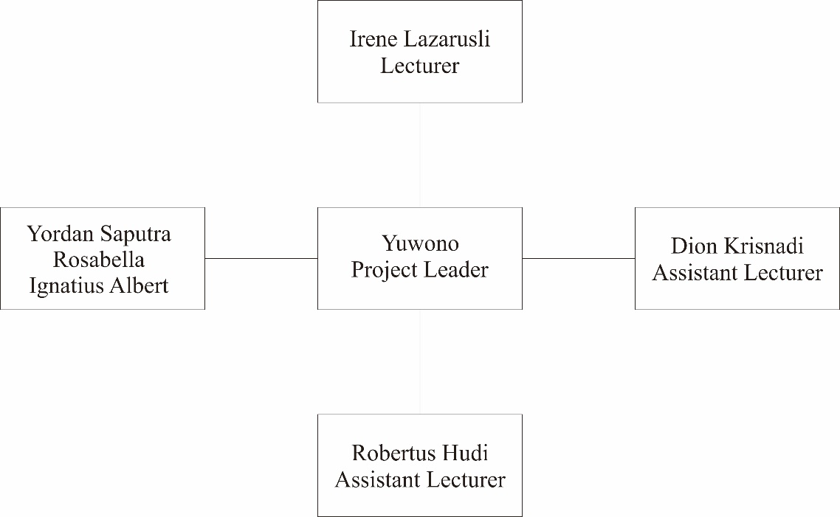

## 2.3 Internal Structure

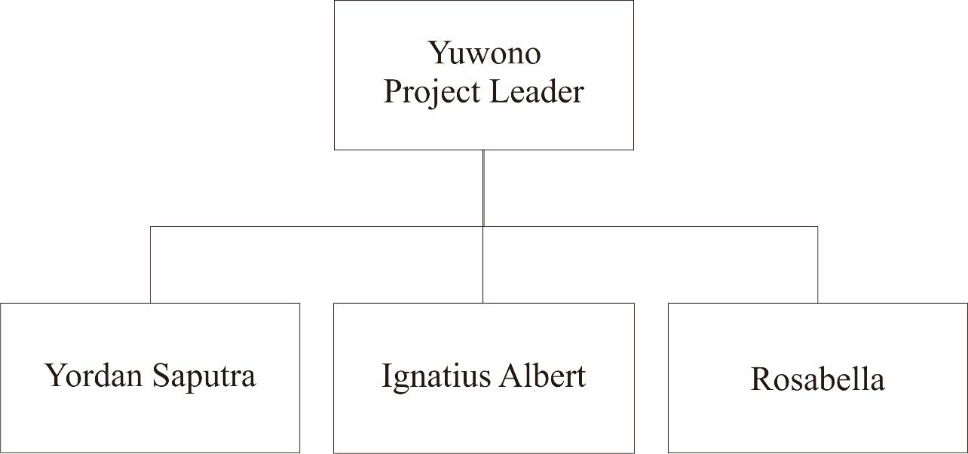

## 2.4 Roles and Responsibilities

Will be attached in Chapter 3.2 Responsibility Assignment Matrix (RAM)

## 2.5 Tools and Techniques

2.5.1. Development Techniques

The project uses NetBeans as a program that our group uses to make this project and the techniques that our group will use are Object Oriented techniques such as inheritance, polymorphism, class, encapsulation, etc.

### 2.5.2. Tools

Operating System

* Microsoft Windows 7
* Microsoft Windows 8

Project Management

* Notepad++
* NetBeans

Documentation

* Microsoft Word 2010

# 

# 

# Chapter 3

**PROJECT MANAGEMENT PLAN**

## 3.1 Work Diagram

|  |  |  |  |  |
| --- | --- | --- | --- | --- |
| ID | Task Name | Start | Finish | Duration |
| 1 | Project Start | 12/7/2014 | 13/7/2014 | 2d |
| 2 | Task distribution for each group member | 15/7/2014 | 15/7/2014 | 1d |
| 3 | Class Diagram production | 21/7/2014 | 24/7/2014 | 4d |
| 4 | Coding from Class Diagram for each group member | 1/8/2014 | 9/8/2014 | 9d |
| 5 | Project Testing | 10/8/2014 | 17/8/2014 | 8d |
| 6 | Coding Revision | 18/8/2014 | 22/8/2014 | 5d |
| 7 | Project Submission | 25/8/2014 | 25/8/2014 | 1d |

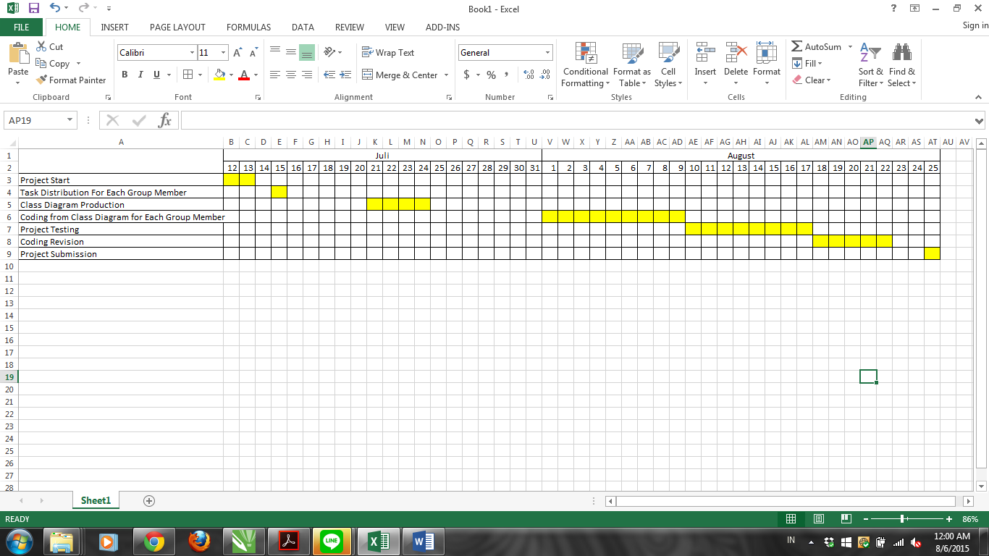

## 3.2 Responsibility Assignment Matrix (RAM)

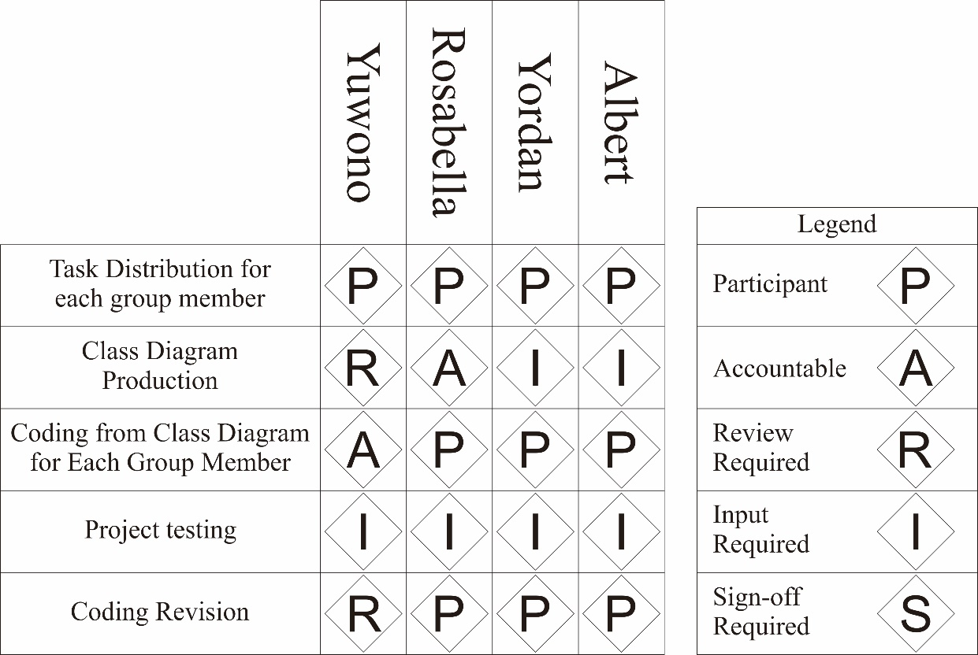

## 3.3 Activity Diagram

